**2010秋季班初二年级英语精练题集 参考答案**

**第一讲**

板块一：

I、1、get a letter from sb. 2、write ( a letter ) to sb. 3、know sth. about … 4、in the top-right corner 5、a girl called May 6、be keen on sports 7、would like to do sth. 8、a date under the address

II、1. from 2. on 3. in 4. near 5. of 6. during 7. in 8. getting 9. enclosed 10. accountant 11. call 12. greeting 13. own 14. engineer

板块二

I. 1-5 BADAD 6-10 DCCAB 11-15 CACAD 16-20 AADBB

II.

1. owner
2. enclosed
3. sign
4. sincerely
5. ambitious
6. probably

板块三

III

(A) 1D 2 C 3 C 4 D 5 B

(B) 1. during 2. actually 3. eyes 4. remember 5. enough 6. although 7. taken

板块四

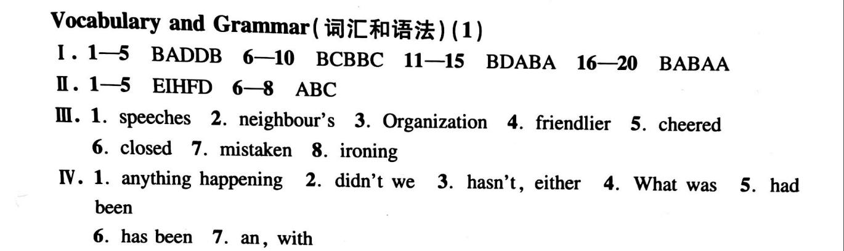

板块五

1. C 2. A 3. D 4. C 5. B 6. A 7. C 8. C 9. A 10. B 11. B 12. D 13. A 14. C 15. C 16. A 17. D 18. B 19. C 20. D

**第二讲**

板块一

一、 1 find out 2 take notes 3 a light brown shirt 4 the white shirt with the long sleeves 5 a blue tie 6 dark brown hair 7 quite long 8 make our voices rise 9 at the end of sentences 10 practise doing sth. 11 a purple roof 12 for the first time 13 introduce one of your friends to the class 14 Write his or her address on the envelope

二、1 an 2 an 3 a 4 with 5 for 6 at 7 to 8 many

三、1 write to 2 take notes 3 know about 4 a photo of 5 in the middle 6 two metres and a half / two and a half metres 7 short black hair 8 walk to school / go to school on foot 9 for the first time 10 in Year/ Grad 7

板块二

(A)

1-5 DBDCA 6-10 DCABC 11-15 DCCCC 16-20 CDBDC

(B) 1.failure 2.success 3.assistance 4.achieved 5.expectation 6.performers

板块三

(A) 1D 2 B 3 C 4 A 5 C

(B) 1. makes 2. while/when 3. energy 4. enough 5. remember 6. through 7. easily

板块四 新概念英语

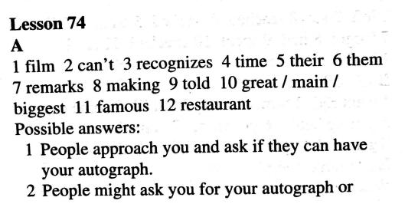 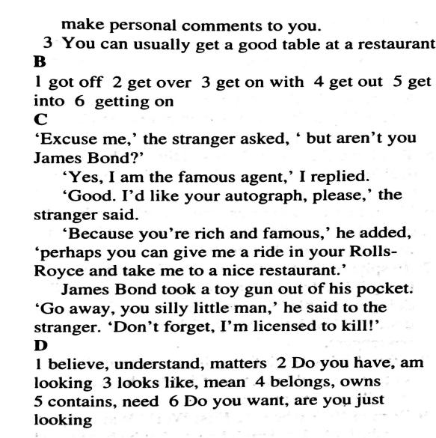

板块五

BCCD

**第三讲**

板块一

一、1 called 2 roofs 3 first 4 physical 5 universities 6 greeting

二、1 I would like to be a football star. 2 First, I will tell you something about myself./ I will tell you something about myself first. 3. Who is the girl in the middle of the photo. 4 My ambition is to be an architect, or maybe an engineer/ My ambition is to be en engineer, or maybe an architect.

三、 1 architect 2 metres 3 accountant 4 during 5 ski 6 enclose

板块二

(A)

1-5 DDCBC 6-10 ACBBC 11-15 BBDBA

(B) 1.Twelfth 2.arguing 3.disappointment 4.experiences 5.hurriedly

6.frightening 7.ambitions 8.yourselves 9.selling 10.complained

板块三

1. 1B 2 C 3 D 4 D
2. 1. borrows 2. faster 3. heart 4. others 5. parents 7. bad 8. control

板块四

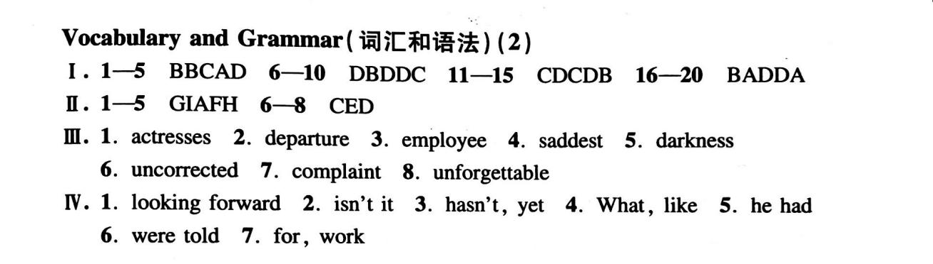

板块五

1-5: BABDC    6-10: ADACA      11-15: BDDBC

**第四讲**

板块一

一、1 be responsible for sales 2 discuss the business 3 in our family car 4 drive me to school 5 make phone calls to … 6 on the way ( to school) 7 start school 8 fail an exam 9 I enjoy seeing my school friends. 10 I sometimes make phone calls to our clients on the way. 11 Some of the work is the work is boring because it is too simple for me. 12 She has already written several successful computer games. Luckily, they are very popular.

二、1 accountant 2 simple 3 discussion 4 sale 5 responsible 6 boring; bored 7 achieved 8 failed

板块二 针对练习

I. 词性转换

1. discussion 2. responsible 3. assistant 4. assisting 5.successful

6.succeeded 7. unsuccessfully 8.achievement 9. sales 10.sellers

III.选择

1.A 2.D 3.C 4. C 5. B 6. C 7. B 8. B 9. C 10.D

板块三 提高部分

(A) 1B 2 C 3 D 4 D

(B) 1. rules 2. forever 3. angry 4. still 5. hated 6. how 7. world

板块四 新概念英语

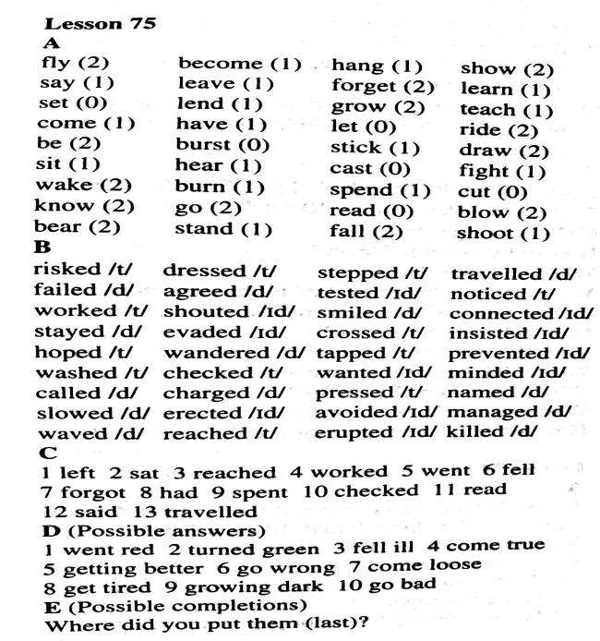 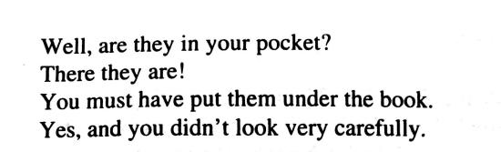

板块五

小题1:The foreign friends are already used to the life in Beijing.  
小题2:James has added his name to the list.  
小题3:To lose weight, we should combine the diet with the exercise.  
小题4:Finally, Jim was persuaded to accept our advice.  
小题5:Whatever you say or do will have an effect on others./The things that you say or do will have an effect on others.

**第五讲**

板块一

一、1 go jogging 2 best subject 3 play badminton 4 healthy food 5 fried food 6 go to school 7 walk home 8 achieve…grades 9 play basketball 10 go to bed 11 At weekends, Amy usually plays badminton with her friend Joan. 12 Twice a week, Megan goes to the Sunny Sports Center for training. / Megan goes to the Sunny sports Center for training twice a week.

二、1 jogging 2 rises 3 heater 4 polite 5 correct 6 Electricity 7 energy 8 training 9 explain 10 fit

板块二：针对练习

I. Choice

1-5DADBB 6-10ADDDB

11-15CBACA

板块三 提高部分

(A) 1B 2 A 3 A 4 D 5 C 6 B

(B) 1. killed 2. slowest/smallest 3. ahead* 4. behind 5. winners 6. future 7. suddenly

板块四

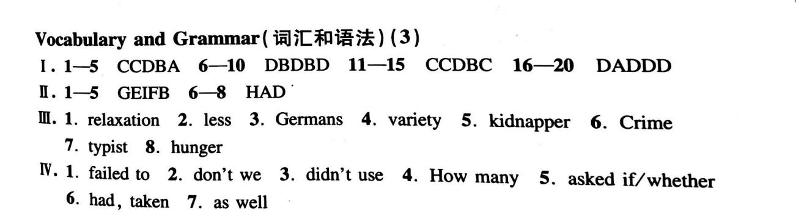

板块五

小题1:seems  are  
小题2:Neither, nor  
小题3:无论你拥有多少金钱，如果你没有一个可以与你一起哭和笑的人，你也不会是一个幸福的人。

**第六讲**

板块一

一、1 healthy 2 jogging 3 electricity 4 popular 5 simple 6 sale 7 pain 8 usual 9 attends 10 repeated

二、1 seldom 2 achieved 3 Luckily 4 fried 5 collects 6 successful 7 top

板块二 针对练习

I. Choice;

1.A 2.C 3.B 4.B 5.D 6.D 7.B 8.C 9.B 10.C

II. Fill in the blanks with the verbs in their proper forms ;

1. will be 2. washed 3. Does, write 4. has, been 5. Became

板块三 提高部分

(A) 1C 2 D 3 A 4 C 5 B

(B) 1. why 2. experience 3. frightened 4. explain 5. already 6. discover 7. without

板块四 新概念英语

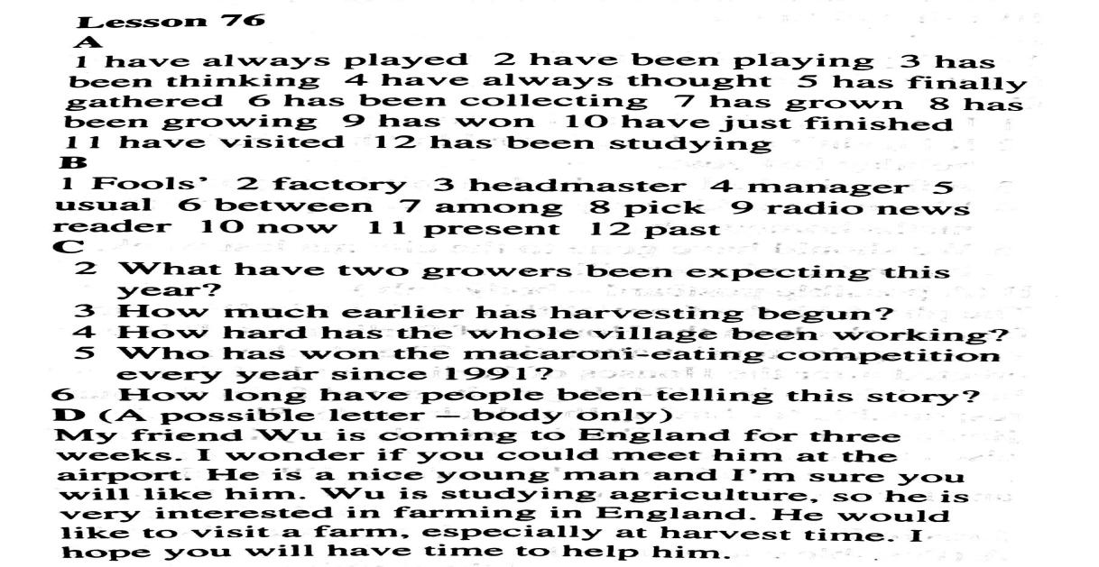

**板块五**

ACBD

第八讲答案

**板块一**

**一、根据中文写出英语词组或句子。★**

1deal with trouble 2 sth happen to sb 3sb happen to do sth

4 argue with sb 5. two women tourists 6. shout at each other

7. stare at the three people 8. move through the crowd

9. What’s going on? / What’s happening? 10. start talking to us

二.根据所给音标写出正确的单词**★**

**1 ever 2 gates 3 trouble 4 postcards 5 happened**

**1 rather 2 details 3 downstairs 4 fighting 5 through**

**板块二**

**I.选择填空：**1-10 DBDAC BCADD 11-20 CCBDD BAABD 21-22BC

**词性转换：**1.argument 2.thieves 3.quiet 4.crowded 5.women

**板块三**

**A. ★★** . C C B A . D

**B.**  C A B . D A C

**板块四**

**Ⅱ.** 26-30.BAAAB 31-35.CCBCB 36-40. ADBCD 41-45. ACDCD

**Ⅲ.** 46-53. AECDBDEA

**Ⅳ.** 54. hers 55. sixties 56. freedom 57. powerful 58. gently 59. death 60. dishonest

61. operate

**V.** 62. Did...use 63. do they 64. either…or 65. What was 66. if/whether... would

67. be caused 68. I apologized to her for breaking the expensive apple watch.

**板块五**

BBDAC

第九讲答案

**板块一：课内知识巩固**

**一、根据中文写出英语词组或句子。★**

1. notice sb. do / doing sth. 2. be gone 3. run away 4. go after sb. = follow sb. 5. be afraid of sb. / sth. 6. pick up the phone/ put down the phone

7. notice / see / hear / watch sb doing sth 8. walk by 9. Well done!

二.根据所给音标写出正确的单词**★**

1. worried 2. arguing 3. hurriedly 4. purse 5. strange

1. fight 2. aboard 3. crowds 4. dialled 5. holds

**板块二：课内巩固与拓展**

选择： 1-10ACDBC ABBCB 11-20 AABAB ABCDA

**改写句子：**1.Did, hear 2.How long 3.What did 4.going on 5.Why does

6.My father didn’t allow me to swim alone.

**词性变换：**1.thieves’ 2.reporters 3.truly 4.hurriedly 5.robbed 6.arguing 7.stranger

8.robbery 9.permission 10.wrong 11.describe 12.amuzement 13.theft

14.runners 15.angrily 16.active 17.stranger 18.useful 19.argued

20.sudden

**板块三：课外阅读与拓展**

**A.** 81.worth 82. perfect 83.share/shared 84. until 85. process 86.between

87. woke

**B.**

88. Twice / Two times /Two

89. Food and the teahouses.

90. By using/adding/They use Sichuanese peppercorn and hot chillies. / People cook dishes using /with peppercorn and hot chillies.

91. Small restaurants in out-of-the-way places that have great tastes./ Small restaurants.

92. No, they don’t./ No.

93. （1）Because of the leisurely andslow-paced lifestyle./ Because it has a leisurely andslow-paced lifestyle. /Part of the reason is the leisurely andslow-paced lifestyle

（2）The city should be much cleaner and safer. /The city should have its own culture and customs. /It should have less cars and pollution. … (Any reasonable answer is acceptable.)

**板块五**

DBCA

第十讲答案

**板块一：课内知识巩固**

**一、根据中文写出英语词组或句子。★**

1. at least / at most 2. an international language 3. in ancient times

4. in many different ways 5. count in the same way 6. in tens

7. make it easier to write big numbers 8. so + a. / ad. that + 从句

9. a modern electronic calculator 10. in a flash 11. do a calculation

12. in one’s whole lifetime 13. like lightning 14. program the computer with instructions

15. solve the problem

二.根据所给音标写出正确的单词**★**

1. invent 2. develop 3. whole 4. Nearly 5. divide

1. system 2. solve 3. powerful 4. accurate 5. against

1. brain 2. degrees 3. Electronic 4. Check 5. language

**板块二：课内巩固与拓展**

**I.选择填空：**1-10 ABABB DCBAB 11-20 BBDAD BCBAC 21D

**III.词性转换：**1.powerful 2.electronic 3.calculating 4.nearly 5.inventions 6.especially

**IV.改写句子：**1.Did, write 2.so, that 3.How much 4.shall we 5.when, over

6.He is going to read the book

**板块三：课外阅读与拓展**

A. 69. D 70. B 71. A 72. C 73. D 74. B

B. 75. B 76. D 77. C 78. A 79. C 80. D

第十一讲答案

**板块一：课内知识巩固**

**一、根据中文写出英语词组或句子。★**

1.look it up 2. some…others… 3. as gentle as sheep 4. die out suddenly

5. know about the lives of dinosaurs 6. the way to be happy

7. own as few things as possible 8. see a boy drinking water

10. become even happier 11. an amusement park

12. be famous for his cartoon characters 13. after leaving school 14. at the same time

二.根据所给音标写出正确的单词**★**

1. though 2. Europe 3. even 4. exist 5. nobody

1. mail 2. while 3. caused 4. dinosaur 5. thinker

1. believe 2. died 3. journey 4. fee 5. government

**板块二：课内巩固与拓展**

**I.选择填空：**1-10 DAACA CCDBD 11-20 ADBDB BDBCD 21-22 DB

**III.词性变换：**1.harmless 2.really 3.amusing 4.owner 5.final 6.characters 7.Greek

8.dead

**IV.改写句子：**1.How much 2.has she 3.same age 4.as/so, as 5.leaving school 6.bad for

7.He will go to school in half an hour.

**板块三：课外阅读与拓展**

A 81. medical 82. abroad/alone 83. basic 84. dangers 85. lock 86. storing 87. form

(81、84和86题写medicine, danger, store分别可得一分。)

B 88. Yes, it is.

89. (She was) a journalist/reporter.

90. She and her family decided to / had to *leave Chile /move to Venezuela/flee her country/run away from ...*

91. Because she wanted to respect her grandfather / (In order) to respect her grandfather.

92. Isabel Allende and her mother talked and even argued a lot about the draft for at least /over a month. /It took Isabel Allende and her mother at least a month to talk about the draft.

1. Isabel Allende is a respectful/ person. She tried her best to write to remember her grandfather. /Isabel Allende is a person with strong wishes. She had a painful life but she was not defeated. /Isabel Allende is a person who’s good at writing. She worked from a journalist to a novelist. /Isabel Allende is a very careful person. She and her mother discussed the draft of the novel a lot.

**第十二讲**

V. 22—26 BBCCA 27—31 BDBAC 32—36 ABABD

. A. 53—58 ABDDAD B. 59—64 DDCCAB

C. 65. obey 66. carry 67. trips 68. enter 69. carefully 70. until 71. first

**第十三讲**

43. loudly 44. favour 45. careful 46. lost 47. navigator

48. didn’t lend 49. Where have 50. can he 51. so, that

1—6 BCCDBA

1—6 ABDCAB

**第十四讲**

1. I had finished my homework when Mum came back.

2. By the time he got there, his friends had already left.

3. They planted a lot of trees between the two buildings.

4. Tom has always been popular among his classmate

22—26 ABABC 27—31 DBBCA 32—36 AABCD

**第十五讲**

43. safety 44. silently 45. decision 46. noisily 47. asleep

48. Was, anything 49. What did 50. shall we 51. so, couldn’t

52. The metal was stronger than any metal we have.

1. They all went to sleep except the young Englishman.

2. Do you know any other foreign language besides English?

3. Being friendly to others is our custom.

4. These songs are usually sung by boys.

5. Do me a favour and close the window.

(A) 74---79 ADDDAC

(B) 80---85 ABADCB

（C）86. However 87. prove 88. world 89. same 90. lower 91. matter 92. deep

(D) 93—98

93. (Only) 25%.

94. Yes, there are.

95. (Until) that summer when he came back to Seoul.

96. In order to be beautiful./ Because they want to be beautiful./The promise of beauty.

97. physical beauty equals happiness.

98. True beauty is happiness and health.(Any reasonable answers are acceptable.)

**新概念答案见第14讲答案**

**第十七讲**

**二、Choose the best answer（选择最恰当的答案）（共20分）**

26．（1分）Which of the following words matches the sound[seif]（　　）

A．save B．safe C．seven D．suffer

【分析】下面的那一个单词的发音和[seif]相匹配？

【解答】答案：B

save的发音是[seɪv]；safe的发音是[seif]；seven 的发音是[sevən]；suffer的发音是['sʌfə（r）]，故选B．

27．（1分）Human beings still can't reach Mars for________ time being．（　　）

A．a B．an C．the D．/

【分析】人类暂时还无法到达火星．

【解答】答案C，for the time being为固定，译为"暂时"，因为现在人类的科学技术水平有限，目前一段时间并不能实现登陆火星，但以后应该会的，所以用"暂时"．

28．（1分）People who have luck never depend ________ luck．（　　）

A．in B．on C．with D．for

【分析】有好运的人从不依赖幸运．

【解答】答案：B

depend on依赖，是固定词组，根据句意：有好运的人从不依赖幸运．．

29．（1分）Tu Yoyo was awarded the Nobel Prize in her ________．（　　）

A．eighties B．eighty C．eightieth D．eightieths

【分析】屠呦呦在八十多岁时获得了诺贝尔奖．

【解答】答案：A．

根据Tu Yoyo was awarded the Nobel Prize in her，可知句子考查在某人几十岁时，用基数词不用序数词，而且应该用复数形式．故选A．

30．（1分）The children enjoyed ________ in the foreign culture festival last night．（　　）

A．himself B．yourself C．ourselves D．themselves

【分析】在昨晚的外国文化节上孩子们玩的很高兴．

【解答】答案：D．

根据The children enjoyed，可知句子考查了短语enjoy oneself 是玩得开心、愉快，主语the children是第三人称复数，则需用反身代词themselves，故选D．

31．（1分）The Chinese team won the Women's Volleyball World Cup ________ September，2015．（　　）

A．in B．at C．on D．by

【分析】2015年9月，中国女排夺得世界杯冠军．

【解答】答案：A．

根据设空处后面的时间"September，2015"可知句子中的时间状语是"2015年9月"，是考查月份前面的介词，用介词in． at+时间点； in+年、月、季节等；on+具体的某一天或某一天的上午/下午/晚上．故选A．

32．（1分）________ hiking in the Gobi Desert is not easy，the girl still decided to have a try．（　　）

A．If B．Although C．When D．As

【分析】即使在戈壁滩远足是一件困难的事，但女孩还是决定试一试．

【解答】答案：B．后句中小女孩决定试一试，即使很难，所以此处应该考察让步状语从句，用于使前后句意发生转折，if和as可以引导条件状语从句，虽然可以用于让步，但在使用时都没有转折意思，所以排除．when引导时间状语从句，这里没有涉及到时间，所以排除．所以选择Althrough，译为即使，表示让步转折．

33．（1分）﹣﹣Look!The students________ their outdoor life lesson on the farm．（　　）

A．take B．takes C．are taking D．took

【分析】﹣﹣看！学生们正在农场上他们的户外生活课．

【解答】答案：C 考查现在进行时．根据题干Look!The students________ their outdoor life lesson on the farm．看！学生们正在农场上他们的户外生活课．从句中的look可知时态是现在进行时．构成是主语+be 动词+动词现在分词 （动词+ing的形式）+宾语，主语是the students是复数，故系动词要用are，take的现在分词是taking，故选择C．

34．（1分）Snoopy is one of________ hunting dogs in the world．（　　）

A．more famous B．most famous

C．the more famous D．the most famous

【分析】史努比是世界上最出名的猎狗之一．

【解答】答案：D，one of the+形容词最高级+名词复数，表示"最…的物品或人物任务之一"，属于固定搭配，应该用形容词最高级，并且其前面要加the，所以选择D

35．（1分）With her teacher's encouragement，the girl works even ________．（　　）

A．hard B．harder C．hardly D．hardest

【分析】在老师的鼓励下，这个女孩更努力了．

【解答】答案：B．考查比较级．句意"在老师的鼓励下，这个女孩更努力了．"，A原级．B比较级．C几乎不．D最高级．根据句意，应该是跟努力了，用副词比较级形式．答案是B．

36．（1分）The light from iPads at night may make you ________ before going to bed．（　　）

A．excited B．exciting C．excitedly D．excitement

【分析】晚上iPad的光线可以让你睡觉前兴奋．

【解答】答案：A 考查ing形容词和ed形容词的区别．根据题干：The light from iPads at night may make you ________ before going to bed．晚上iPad的光线可以让你睡觉前兴奋．根据句子结构要用形容词作宾语补足语（即构成复合宾语）．excited和exciting是形容词，excitedly是副词，excitement是名词，故先排除C、D．excited一般主语是人，exciting一般主语是物，本题主语是you，故选择A．

37．（1分）The restaurant needs ________ thirty chairs for the coming guests．（　　）

A．other B．the other C．others D．another

【分析】这个饭店需要另外30把椅子给即将到来的客人．

【解答】答案D．句意"这个饭店需要另外30把椅子给即将到来的客人．"，A选项other 另一个，后通常+名词．B选项the other指的是两个人或两件东西中的"另一个"，通常用于one…the other…：一个…另一个…C选项others其余的（指代的为复数名词）．D选项another另外的（通常指三个或以上的），根据thirty chairs三十把椅子，可知答案是D．

38．（1分）The tourists have no idea ________ to meet the tour guide at 7o'clock tomorrow morning．（　　）

A．what B．when C．which D．where

【分析】游客们不知道明天早上7点在哪里见导游．

【解答】答案：D，在句子后边，指出具体的时间，早上7点，所以排除when，根据句意，并不是和导游做什么（what）或找哪一个（which）导游，而是缺少地点．所以用where来引导定语从句，表明地点，选择D

39．（1分）﹣﹣Must I finish the work today？

﹣﹣________．The manager is looking forward to it．（　　）

A．Yes，you must． B．Yes，you can．

C．No，you mustn't D．No，you needn't．

【分析】﹣﹣今天我必须完成这项工作吗？

﹣﹣是的，你必须完成．经理正期待着工作的完成．

【解答】答案：A．

根据The manager is looking forward to it，可知经理正期待着工作的完成，所以你必须完成，以Must引导的一般疑问句，肯定回答依然用must．故选A．

40．（1分）Americans________ New York City"The Big Apple"since 1971．（　　）

A．call B．called C．has called D．have called

【分析】自1971以来，美国人把纽约称为"大苹果"．

【解答】答案：D．

根据时间状语从句since 1971，强调过去发生的事情一直持续到现在，包括现在在内，判断主句用现在完成时．现在完成时的构成是：主语+have/has+动词的过去分词；主语是Americans是复数形式，助动词用have，故选D．

41．（1分）The exchange students will________ for Sydney during their winter holiday．（　　）

A．keep off B．set off C．get off D．turn off

【分析】交换生们将在寒假期间动身去悉尼．

【解答】答案：B

根据选项的意思keep off 不接近，避开，让开；set off 出发，动身；get off 下来，脱下，下车turn off 关掉，关上，结合题干中的关键词for Sydney，可联想短语set off for someplace即"动身去某地"故填set off，故选B

42．（1分）________ wonderful it is to produce Chinese first large passenger aircraft!（　　）

A．What a B．What C．How D．How a

【分析】生产中国第一架大型客机是多么的美妙啊！

【解答】答案：C．

根据wonderful it is to produce Chinese first large passenger aircraft!可知这里考查了感叹句，本句的中心词是wonderful，它是一个形容词，根据How+形容词/副词+主语+谓语!故选C．

43．（1分）One of the basic ways of improving your memory is_______．（　　）

A．use the link method B．to use the link method

C．used the link method D．uses the link method

【分析】提高记忆力的一种基本方法是采用联想的方法．

【解答】答案：B．考查不定式．句意"提高记忆力的一种基本方法是采用联想的方法．"a way to do sth做某事的一种方法．这里的不定式做表语．答案是B．其它不正确．

44．（1分）﹣﹣You look so sad，William．What's the matter with you？

﹣﹣________．（　　）

A．I've lost my wallet．

B．I'm very happy．

C．I've won the first prize．

D．I don't agree with you．

【分析】﹣﹣你看起来很伤心，威廉，你怎么了？﹣﹣我的钱包丢了．

【解答】答案：A 考查常用日常交际用语．根据题干：You look so sad，William．What's the matter with you？你看起来很伤心，威廉，你怎么了？可知发生了不幸的事，I've lost my wallet．译为我的钱包丢了，I'm very happy译为我很高兴，I've won the first prize．译为我获得了第一，I don't agree with you．译为我不同意你的观点，结合语境选择A．

45．（1分）﹣﹣In my opinion，buying second﹣hand books can save students a lot of money．﹣﹣________．（　　）

A．That's all right． B．I'm sorry to hear that．

C．I think so，too． D．It's my pleasure．

【分析】﹣﹣在我看来，买二手书可以节省学生很多钱．﹣﹣我也这么认为．

【解答】答案：C 考查常用日常交际用语．根据题干：﹣In my opinion，buying second﹣hand books can save students a lot of money．﹣﹣在我看来，买二手书可以节省学生很多钱． That's all right．译为没关系；I'm sorry to hear that．译为 很遗憾听到这个消息；I think so，too．译为我也这么认为，表示赞同； It's my pleasure．译为 乐意效劳，结合语境选择C．

**三、Completethefollowingpassagewiththewordsorphrasesinthebox.Eachcanbeusedonlyonce.（将下列单词或词组填入空格．每空限填一词，每词只填一次）（共8分）**

46．（4分）

|  |
| --- |
| A filed B large C anything D through E nothing |

A rich man loved crocodiles so much．Once he bought a new house．There was a（46）　large　 swimming pool in the back．However，it was （47）　filed　 with fierce crocodiles．One day the man had a party to show off the big house as well as his favorite pets．

As the man expected，no one dared o stand next to the pool．"I think a real hero

should have courage，"shouted the man．"If anyone is brave enough to swim （48）　through　the crocodiles and make it to the other side，I will give that person（49）　anything　 he wants．I will give him my job，my money，my house，and my crocodiles!"

【分析】一个富人很喜欢鳄鱼，有一次他买了一个新的房子，后面有一个大的游泳池，然而，它充满了凶猛的鳄鱼，有一天，这个男人有一个聚会来炫耀大房子，以及他最喜欢的宠物．正如所预料的那样，没有人敢站在游泳池旁边，"我想一个真正的英雄应该有勇气，"这个人喊道，"如果有人足够勇敢地游泳穿过这些鳄鱼，并游去另一边，我会给他任何他想要的东西，我会给他我的工作，我的钱，我的房子，我的鳄鱼！"

【解答】【46】答案．B．填形容词．句意：后面有一个大的游泳池．根据所给单词句意可知用large大的．答案是B．

【47】答案．A．考查固定词组，句意：它充满了凶猛的鳄鱼． be filled with充满，答案是A．

【48】答案．D．考查介词．在泳池中从鳄鱼中穿过去，用through穿过．答案是D．

【49】答案．C．考查不定代词．句意：我会给他任何他想要的东西，根据句意及所给单词可知，用anything任何东西．答案是C．

50．（4分）

|  |
| --- |
| A serious B，luckily C．pushed D crazy E．words |

Everyone laughed at the （50）　crazy　 idea．They thought it was a joke，and then left the pool area．Suddenly，they heard a loud splash （扑通声）．Everyone turned around and saw a man swimming for his life．The crocodiles tried to reach him quickly，but he swam to the other end and escaped from them（51）　luckily　．

"Wow，unbelievable．He made it!"cried the rich man．"I keep my（52）　words　．Tell me what you want and what I can do for you．"

The friend finally got his breath back．Then he looked up and said，"You can tell me who（53）　pushed　 me into the pool!"

【分析】每个人都嘲笑这个疯狂的想法，他们认为这是一个玩笑，然后离开了游泳池区，突然，他们听到一个响亮的扑通声，每个人都转过身来，他们看见一个男人正在池子里拼命地游泳．鳄鱼试图快速地找到他，但他游到另一端，并幸运地从鳄鱼群里逃脱．"哇，难以置信．他成功了！"有钱人喊道，"我遵守我的诺言．告诉我你想要什么，我能为你做什么．"这个朋友终于喘了口气，然后他抬起头说："你可以告诉我是谁把我推进游泳池的！"

【解答】50．答案：D．考查形容词．句意：每个人都嘲笑这个疯狂的想法．根据句意及所给单词可知用crazy疯狂的．答案是D．

51．答案：B．考查副词．句意：并幸运地从鳄鱼群里逃脱．根据句意及所给单词可知用luckily幸运地．答案是B．

52．答案：E．考查词组．句意：我遵守我的诺言．keep one's words遵守某人的诺言．答案是E．

53．答案：C．考查词组．句意：你可以告诉我是谁把我推进游泳池的！push into推进，一般过去式用push的过去式pushed．答案是C．

**四、Completethesentenceswiththegivenwordsintheirproperforms（用括号所给单词的适当形式完成下列句子．每空格限填一词）（共8分）**

54．（1分）The detective dealt with many　cases　 with the help of his assistant．（case）

【分析】在助手的帮助下，那个侦探处理了许多案件．

【解答】答案：cases．

提示词是名词，意思是"案件"，根据所给单词结合语境可以推测句意为"在助手的帮助下，那个侦探处理了许多案件．"，根据设空处前面的many判断填名词复数形式，故答案为：cases

55．（1分）A good　driver　 should always keep his eyes on road．（drive）

【分析】一个好的司机应该总是把精力集中在路上．

【解答】答案：driver．

提示词是动词，意思是"驾驶"，根据所给单词结合语境可以推测句意为"一个好的司机应该总是把精力集中在路上．"，根据设空处前面的a good判断填名词单数，故答案为：driver．

56．（1分）It is　foolish　 of you to waste so much time in watching TV．（fool）

【分析】你浪费这么多时间看电视是很愚蠢的．

【解答】答案：foolish．

提示词是名词，意思是"傻瓜"，根据所给单词结合语境可以推测句意为"你浪费这么多时间看电视是很愚蠢的．"，根据句子所在的句式It's+形容词+of sb．+to do sth．判断填形容词"愚蠢的"，故答案为：foolish

57．（1分）Please measure the　length　 of the rope with the ruler．（long）

【分析】请用尺子测量一下这根绳子的尺度．

【解答】答案：length．

提示词是形容词，意思是"长的"，根据所给单词结合语境可以推测句意为"请用尺子测量一下这根绳子的尺度．"，根据设空处前面的the判断填名词"长度"，故答案为：length

58．（1分）Peter's father seemed　unhappy　 with his spelling mistakes．（happy）

【分析】Peter的爸爸对他的拼写错误似乎很不开心．

【解答】答案：unhappy．

提示词是形容词，意思是"开心的"，根据所给单词结合语境可以推测句意为"Peter的爸爸对他的拼写错误似乎很不开心．"，根据设空处前面的seemed结合句意判断填形容词"不开心的"，故答案为：unhappy

59．（1分）The book　mainly　 tells us that travelling will make our life colorful．（main）

【分析】这本书主要告诉我们旅游会使我们的生活丰富多彩．

【解答】答案：mainly．．

提示词 是形容词，意为"主要的"，根据所给单词结合语境可以推测句意为"这本书主要告诉我们旅游会使我们的生活丰富多彩．"，设空处的单词修饰动词tell 且意思是"主要地"，所以应填提示词的副词形式 mainly．，故答案为：mainly．

60．（1分）Young people can learn to take care of others by　raising　 pet．（raise）

【分析】年轻人可以通过饲养宠物来学习照顾其他人．

【解答】答案：raising．考查动名词．句意"年轻人可以通过饲养宠物来学习照顾其他人．"，by介词，后加动名词．raise的动名词是raising养育、饲养．答案是raising．

61．（1分）Shall we　collect　 some information from Internet to finish our report？（collection）

【分析】我们从网上收集一些信息来完成我们的报告好吗？

【解答】答案：collect 考查动词．句意"我们从网上收集一些信息来完成我们的报告好吗？"，根据语境，及情态动词shall，可知应该用动词原形．collection收集，名词．动词是collect．

**五、Completethefollowingsentencesasrequired.（根据所给要求完成句子．62-67小题每空格限填一词）**

62．（1分）Bruce wrote some letters to his pen friend last month．（改为否定句）

Bruce　didn't　　write　any letters to his pen friend last month．

【分析】布鲁斯上个月给他的笔友写了一些信．

【解答】答案：didn't write

根据句中的动词wrote是动词的过去式，改否定句和一般疑问句时，借助于助动词do的过去式did，再把动词的过去式改为动词原形．

63．（1分）I borrowed some books from Shanghai Library twice a month．（划线部分提问）

　How　　often　 do you borrow some books from Shanghai Library？

【分析】我从上海图书馆中每月借书两次．

【解答】答案：How often

通过观察划线部分的短语twice a month，可知是就频率提问，应用how often，意为"多久一次"．

64．（1分）The teacher didn't tell us whether we should go on with the discussion or not．（改为简单句）

The teacher didn't tell us　whether　　to　go on with the discussion or not．

【分析】老师没有告诉我们我们应该是继续讨论还是不讨论．

【解答】答案：whether；to

根据所给第一个句子，可以看出本句子是一个宾语从句，宾语从句可以转换为特殊疑问词+to do sth，故空白处应填whether；to．

65．（1分）The captain will choose ten boys to work as volunteers．（改被动）

Ten boys will　be　　chosen　to work as volunteers．

【分析】队长将会选10个男孩去做志愿者的工作．

10个男孩将会被选为做志愿者的工作．

【解答】答案：be chosen

根据句型转换的要求可知是改为一般将来时的被动语态，一般将来时被动语态的构成：主语+will+be+动词的过去分词，choose的过去分词是chosen．

66．（1分）Sally could not understand the English film she saw last night．（改为反义疑问句）

Sally could not understand the English film she saw last night，　could　　she　？

【分析】莎莉不能理解她昨天晚上看过的英语电影．

莎莉不能理解她昨天晚上看过的英语电影，是吗？

【解答】答案：could；she

改反义疑问句时，要按照：前面句子是肯定，后面句子用否定；前面句子是否定，后面的句子用肯定的原则．根据句意和联系句中出现的could not，可知前面的句子是否定句，后面的句子用否定形式，又因为本句子是一个定语从句，其先行词是the English film，后面的从句she saw last night是省略了关系代词that或which的定语从句，故变反意疑问句时，看主句的时态，应填could；she．

67．（1分）The cook was too busy to notice the overcooked soup．（保持句意不变）

The cook was　so　 busy　that　 he didn't notice the overcooked soup．

【分析】这位厨师太忙了而没有注意到煮得过久的汤．

这位厨师是如此的忙以至于没有注意到煮得过久的汤．

【解答】答案：so；that

根据所给的第一个句子中出现的固定句型too+形容词+to do sth，意为"太…而不能去做某事"，其同义句型为so+形容词/副词+that从句，意为"如此…以至于…"，故答案为so；that．

68．（1分）the bills，very，added up，the waiter，accurately （连词成句）

　Thewaiteraddedupthebillsveryaccurately．　﹣﹣

The waiter added up the bills very accurately．

【分析】﹣﹣服务员很准确地把账单加了起来．

【解答】答案：The waiter added up the bills very accurately． 考查连词成句．主语是the waite，add…up把…加起来是固定搭配，the bills是宾语，very accurately作宾语补足语，故答案是The waiter added up the bills very accurately．

【分析】"蒙娜丽莎"吸引了全世界的艺术爱好者．你知道达芬奇还画了一个"前蒙娜丽莎"吗？它明年将在上海展出．本文介绍的是Joel Feldman，蒙娜丽莎基金会的秘书长，接受了一个关于绘画和组织的采访．

【解答】69．B细节理解题，根据In 1913，Hugh Blaker，a manager of the Holburne Museum in England，found the"Earlier Mona Lisa"and brought it to his museum．可知The Holburne Museum是"前蒙娜丽莎"文章中的第一个主人，故答案为：B．

70．C细节理解题，根据In the end，28 out of the 29 experts believe this is certainly the painting created by Lenardo da vinci．最后，大多数专家认为这肯定是Lenardo da vinci创作的画．可知研究的目的是谁画的这幅画，故答案为：C．

71．A细节理解题，根据下一句：Believe me，there is really something amazing that occurs when you are in the presence of this painting．相信我，当你出现在这幅画面前的时候，会发生一些令人惊奇的事情，可知此处应该是：我完全惊呆了，故答案为：A．

72．D细节理解题，根据Therefore，we decided to begin its Asian tour and Shanghai obviously would be the first stop因此，我们决定开始亚洲之行，上海显然是第一站，因为要在亚洲进行展示，所以接下来肯定还是亚洲的城市，故答案为：D．

73．D细节理解题，根据文中最后一句提到But visitors will be able tocome quite close to the painting但游客会接近画，不是组织者为了保持这幅画的安全采取的措施，故答案为：D．

74．C细节理解题，根据文章内容可知本文是关于艺术的，所以很显然会出现在艺术版块，故答案为：C．

【分析】文章讲述了中国结束了一孩政策，开放二孩政策，并提到了一个家庭有两个孩子的好处和坏处．

【解答】75．B 考查动词．A表示使；B表示结束；C表示开始；D表示带走．由Every couple can have two children可知此处表示中国结束了长久以来的一孩政策，选B．

76．A 考查短语．A表示与…玩；B表示寻找；C表示疲倦；D表示捡起．由You may not feel lonely可知此处表示因为有人与他们一起玩，选A．

77．B 考查名词．A表示问题；B表示注意力；C表示证明；D表示借口．由share things可知此处讲的是要与兄弟姐妹分享的东西，除了上述提到的，还有父母的关注，选B．

78．A 考查连词．A表示或者，否则；B表示并且；C表示所以；D表示但是．结合语境可知此处表示有兄弟姐妹的孩子们需要学会妥协和控制他们的感受，否则会对家庭关系带来坏影响，选A．

79．C 考查名词．A表示方法；B表示需求；C表示性格；D表示意义．下文提到的responsible and eager和funny and creative都指的是性格方面，选C．

80．D 考查形容词．A表示疑惑的；B表示沮丧的；C表示无望的；D表示放松的．由Thus late﹣born kids are usually funny and creative可知此处表示他们更放松，选D．

【分析】【文章大意】本文介绍的金子．文章介绍了它的特性、历史、用途、价值等．

【解答】81．air．考查被动语态．句意为：它不受空气或水的影响．分析句子成分可知，空格处为介词by的宾语，故填名词．本句是被动语态．连词or连接的是两个并列的成分，金子不受两种东西的影响，其中一种是水，再结合首字母提示，就可确定填为air（空气）．air or water水或空气．故填air．

82．belonged．考查一般过去时．句意为：他们相信，所有金子都是属于其国王法老的．分析句子成分可知，空格处为谓语，故填动词．根据句意，并结合首字母提示和英语提示"to"，确定填belong的某种形式．belong为动词，意思是"属于"．belong to属于．主句为一般过去时，主句也用一般过去时，表示他们过去认为如何如何．belong的过去式为belonged．故填belonged．

83．decorate．考查不定式．句意为：今天，金叶仍然用来装饰家具和其他东西．分析句子成分可知，空格前面为不定式符号，故填动词原形．根据句意和英语提示"furniture"，并结合首字母提示，确定填decorate．decorate为动词，意思是"装饰"．这里to decorate furniture and other things作为状语，表示目的（用途）．故填decorate．

84．cheaper．考查形容词比较级及"make+名词（宾语）+形容词（补足语）"句式．句意为：这不但使宝石廉价，而且使其更硬．分析句子成分可知，空格处为宾语补足语，故填形容词．本句为"make+名词（宾语）+形容词（补足语）"句式．本句还属于"not only，but also"句型，连接的是两个对等的成分；根据后半句，形容词为比较级，故这里也应填比较级．根据句意，并结合首字母提示，确定填cheaper．cheap为形容词，其比较级为cheaper，意思是"更便宜"．make things cheaper使东西更便宜．故填cheaper．

85．common．考查形容词．句意为：因为它不常见，因而价值高．分析句子成分可知，空格处为表语，故填形容词．根据后半句"and therefore had a high value"可知，物以稀为贵，结合首字母提示，确定填common．common为形容词，意思是"常见的；普通的"．not common不常见．故填common．

86．instead．考查副词．句意为：今天我们用很多纸张（纸币）来代替．分析句子成分可知，空格处为状语，故填副词．根据句意，并结合首字母提示，确定填instead．instead为副词，意思是"代替"．故填instead．

87．under．考查介词．句意为：在世界很多地方发现了金子，它们通常深埋于地下．分析句子成分可知，逗号之后为状语，故填介词．根据句意，并结合首字母提示和英语提示"the ground"，确定填under．under为介词，意思是"在…下面"．under the ground在地下．故填under．

【分析】这篇文章主要介绍了急诊室故事已成为流行的节目．我们已经习惯了这样的真人秀节目，中国好声音，爸爸去哪，这些节目只想取悦于人．观众可能会觉得看的时候他们很有趣．但是急诊室故事让我们深入别人的生活．给我们一个机会去幕后看看医院的工作和医务人员如何努力工作．它让我们想象在类似的压力下我们会有怎样的反应，这也让我们明白我们是多么的幸运．

【解答】答案：88．Yes，they do．细节理解题．根据第一段第三行句子In the end，the doctors manage to save the young boy's leg．最后，医生们设法救了小男孩的腿．可知答案是肯定的．故答案为Yes，they do．

89．Audience may think them interesting and funny while watching．细节理解题．根据第二段第二行句子These shows only want to amuse people．Audience may think them interesting and funny while watching．这些节目只想取悦于人．观众可能会觉得看的时候他们很有趣．故答案为Audience may think them interesting and funny while watching．

90．Reality TV had its beginning in Europe in the early 1990s．细节理解题．根据第三段第一行句子Reality TV had its beginning in Europe in the early 1990s．电视真人秀节目在欧洲在1990年代初开始．故答案为Reality TV had its beginning in Europe in the early 1990s

91．The producers．细节理解题．根据第三段第一行句子These shows are not real documentaries（纪录片），but focus on personal dramas and difficulties controlled by the producers to catch more people's eyes．这些节目并不是真正的纪录片，而是专注于个人的戏剧和困难由制作商控制捕捉更多的人的眼睛．可知是制造商使真人秀更有吸引力．故答案为The producers．

92．Because it is human nature can not be controlled．细节理解题．根据第四段第一行句子Some audience may feel uncomfortable，but we can't help watching，because it's human nature to be attracted by the ups and downs of the lives of other human beings．有些观众可能觉得不舒服，但是我们忍不住看，因为这是人的本性被他人的起起落落的生活所吸引．故答案为Because it is human nature can not be controlled．

93．Yes，it is．It allows us to imagine how we might react in similar stressful situations．细节理解题．根据倒是第三行句子The Story in ER gives us a chance to go behind the scenes and see how hospitals work and how hard the medical staff work．It allows us to imagine how we might react in similar stressful situations．It also lets us appreciate how lucky we are．急诊室故事给我们一个机会去幕后看看医院的工作和医务人员如何努力工作．它让我们想象在类似的压力下我们会有怎样的反应，这也让我们明白我们是多么的幸运．可知答案是肯定的．故答案为Yes，it is．It allows us to imagine how we might react in similar stressful situations．

**第十八讲**

Part 2

V. 22—26 BBACD 27—31 BBCBC 32—36 BAADA

VI. 37—42 GCEAFB

VII. 43. safely 44. attracted 45. freedom 46. solve 47. succeed

VIII. 48. Did, have 49. more powerful 50. do, favour 51. will you

52. It was too cold to go swimming yesterday morning.

VI. ( A ) 69. B 70. A 71. D 72. C 73. A 74. B

( B ) 75. D 76. C 77. C 78. B 79. A 80. D

( C ) 81. seldom 82. wish 83. readers 84. impossible

85. attract 86.discuss 87. enjoyable

( D ) 88. (It aims) to protect the environment.

89. In 1977.

90. No, it doesn’t.

91. Money.

92. By starting gardens and growing plants that are local to their area.

93. Because the organization helps make the world a better place to live in.